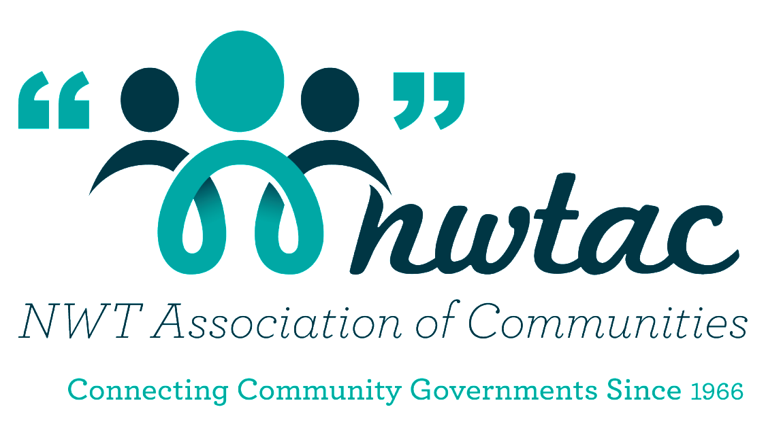

NWTAC
Climate Change Resilience Award

Sponsored by:

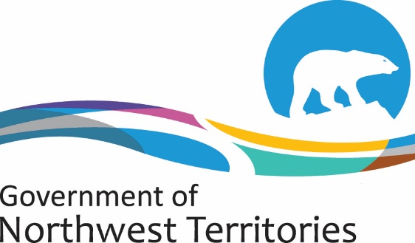

Environment and Natural Resources

Award Description
Goal
- Celebrate an NWT community that demonstrates leadership in climate change adaptation.
- Honour a community that is taking a pro-active approach to the challenges caused by climate change and has strengthened community resilience through their actions!

Eligibility
All 33 community governments in the NWT

Criteria
Demonstrate how your community is taking action to address climate change impacts and build resilience. Some examples include:
- Mainstreaming climate change into existing budgets, policies and bylaws, operations, and planning.
- Offering opportunities and programs for residents to learn and take action to become more resilient to climate change (such as community gardens, fire smarting, harvesting and cultural programming);
- Undertaking planning and assessment projects to identify climate change risks and vulnerabilities and develop tools and plans to build resilience.
- Taking steps to make infrastructure more resilient to climate change.
- Partnering and communicating with other organizations, communities, and other levels of government to support climate change adaptation; and
- Participating in related training, pilot studies, workshops etc.

Award
$5000 to go towards a resilience-building initiative in the winning community.

Complete the Nomination form and include an explanation of why your community should receive the Climate Change Resilience Award. Tell us how you as a community are actively promoting resilience in the face of a changing climate.

Deadline for Nominations: February 19, 2021

Community Nomination Form

NOMINEE INFORMATION

Community Name: ______________________________________________________
Person nominating: _____________________________________________________
Address: ___________________________________________________________
___________________________________________ Postal Code: ______________
Work Phone: ___________________________ Fax: ___________________________
E-mail: _______________________________________________________________

Signature: _______________________________ Date: ___________________

Please let us know what your community has done to build resilience and adapt to a changing climate. Please attach any additional information.

NWT Association of Communities
Tel: 867-873-8359 or 1-866-973-8359
Fax 867-873-3042
E-mail: yvonne@ntwac.com

