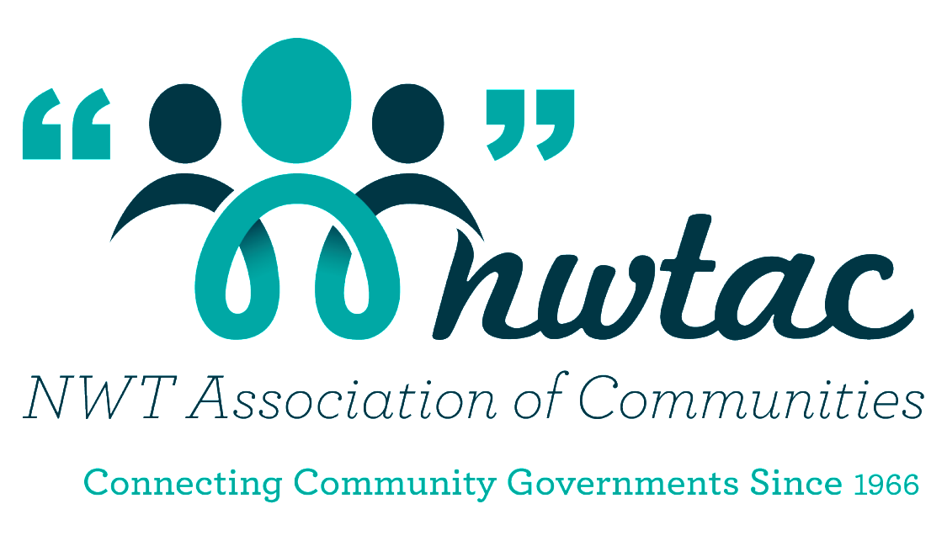

NWTAC
Community Builder Awards

Sponsored by:

CONTENTS

- Nomination form (3 pages)
- Brief description of each award including eligibility and criteria

APPLICATION CHECK LIST

Before you submit your completed nomination package, check for:

- Signatures (both yours and the nominees);
- Nomination form with all applicable areas completed;
- Short biography of nominee;
- Two (2) letters of support
- Supporting documents which will assist the Awards Committee in determining whether a nominee meets the criteria of the specific Award

The above documents should be mailed, faxed, e-mailed or delivered to:

NWT Association of Communities
#200, 5105 – 50th Street
Yellowknife, NT X1A 1S1
Tel: 867-445-9609 or 1-866-973-8359
Fax 867-873-3042
E-mail: yvonne@nwtac.com

For more information visit the NWTAC website.

Deadline for Nominations: February 19, 2020

Award Descriptions

The aim of the Community Builder Awards is to celebrate excellence among elected officials, honour long-serving members of the NWTAC, and recognize individuals and organizations that have contributed to and improved the well-being of residents within our Member Communities. AON’s kind sponsorship of these awards goes a long way in assisting the NWTAC to recognize leadership and innovation across the NWT.

There are three categories in which a Member Community can submit a nomination:

- Community Builder

This award recognizes a past or current Elected Official who has provided exemplary leadership on council and in their community.

Eligibility
- Must be or have been an elected official of an NWTAC Member Community;
- Must be nominated by an NWTAC Member Community in Good Standing.
Criteria
- Active in community organizations outside of their duties on council;
- Responsible for innovation in how the council/community government operates.

- Community Service Award

This award recognizes an individual, an organization, or a business that has demonstrated exemplary service to Member Communities in the NWT. This could be in the area of infrastructure development, volunteerism, youth development or other significant contributions.

Criteria
- Has made a significant contribution in improving the well-being of a NWT Community and its residents.

- Roll of Honour (Long Service)

Elected Officials who have served for 15 years or longer on a Member Community Government are eligible to be named to the NWTAC’s Roll of Honour.

Eligibility
- Served on a Member Community Government for at least 15 years

Nomination Form (Page 1 of 3)

NOMINEE INFORMATION

Award Category (Check one):
Community Builder ___ Roll of Honour (Long –Service) ___ Community Service ___

Nominee’s Name: _______________________________________________________
Organization: __________________________________________________________
Address: ___________________________________________________________
___________________________________________ Postal Code: ______________
Work Phone: ___________________________ Fax: ___________________________
E-mail: _______________________________________________________________

NOMINEE’S ACCEPTANCE

I, ________________________________________________ accept the nomination for the NWTAC Community Builder Awards. I give consent to publication of my photograph and information as a recipient for further usage of promotion of the NWTAC Community Builder Awards by the NWT Association of Communities and/or AON.

Signature: _______________________________ Date: ___________________

Nomination Form (Page 2 of 3)
NOMINATOR INFORMATION

Please complete the following information. The Awards Committee may contact you during the selection process.

Name: ________________________________________________________________
Organization:___________________________________________________________
Address: ______________________________________________________________
___________________________________________ Postal Code: ______________
Work Phone: ___________________________ Fax: ___________________________
E-mail: _______________________________________________________________

Signature: __________________________________ Date: ___________________

Nomination Form (Page 3 of 3)

ADDITIONAL NOMINEE INFORMATION

The following information must be included when submitting a nomination:

- Biography of Nominee

Please provide us a short (1-2 page), biography of the nominee. It should be specific in discussing which way the nominee has portrayed him/herself as fitting the criteria within the chosen award category. Their accomplishments and contributions to the community should be included.

- Letters of Support

Please provide us with two (2) letters of support. These letters should outline the nominee’s accomplishments in relation to the award category.

PLEASE NOTE: Letters of Support are not required for Roll of Honour (Long-Service Award).

- Supporting Documents

Please provide any documentation that will assist the Awards Committee in determining whether a nominee meets the criteria of the specific Award. This could include newspaper articles, an individual’s resume, copies of thank you letters etc.

PLEASE NOTE: The only document required for the Roll of Honour (Long-Service Award), is a letter from the Mayor/Chief or a Senior Administrative Officer/Band Manager which confirms the nominee has served 15 years on Council.

