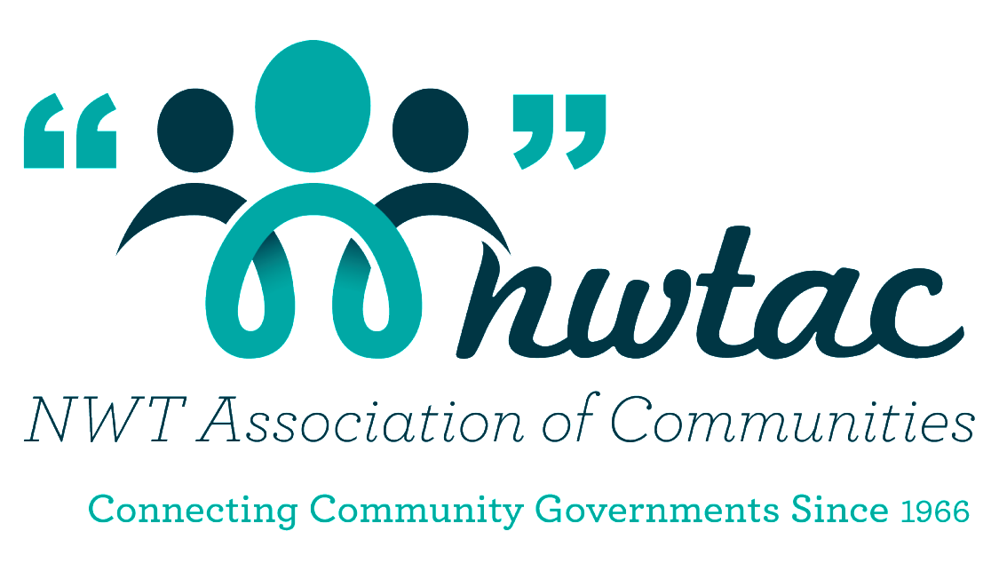

NWTAC
Energy Excellence Award

Sponsored by:

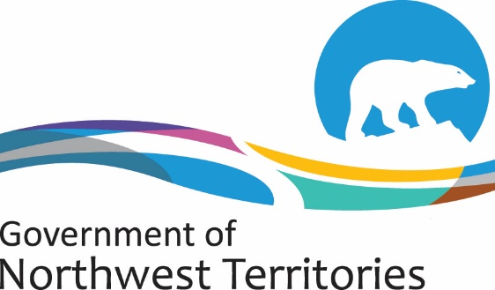

Department of Infrastructure

Award Description
Goal
- Celebrate an NWT community that demonstrates leadership in improving energy efficiency and reducing greenhouse gas emissions.

Eligibility
All 33 community governments in the NWT

Criteria
Demonstrate how your community is taking action to improve energy efficiency and reduce emissions. Some examples include:
- Mainstreaming energy efficiency and emissions reduction into existing budgets, policies and bylaws, operations, and planning.
- Taking steps to make infrastructure and operations more energy efficient including completing energy audits and implementing recommendations.
- Undertaking planning and assessment projects (for example updating a community energy plan, determining energy footprint, identifying opportunities to switch to renewable energy sources)
- Offering opportunities and programs for residents to learn and take action to reduce their carbon footprint.
- Partnering and communicating with other organizations, communities, and other levels of government to support energy efficiency and emissions reductions; and
- Participating in related training, pilot studies, workshops etc.

Award
$5000 to go towards an energy efficiency or emissions reduction initiative in the winning community.

Complete the Nomination form and attach with that an explanation why your community should receive the Energy Excellence Award. Tell us some amazing stories of how you as a community provide, promote, and work at confronting the energy challenge in our northern communities.

Deadline for Nominations: February 19, 2021
Community Nomination Form

NOMINEE INFORMATION

Community Name: ______________________________________________________
Person nominating: _____________________________________________________
Address: ___________________________________________________________
___________________________________________ Postal Code: ______________
Work Phone: ___________________________ Fax: ___________________________
E-mail: _______________________________________________________________

Signature: _______________________________ Date: ___________________

Please let us know what your community has done to support the energy challenge in your community and why you should receive the award. Please attach any additional information.

NWT Association of Communities
Tel: 867-445-9609 or 1-866-973-8359
Fax 867-873-3042
E-mail: yvonne@ntwac.com

